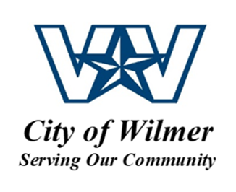
Utility Lineman
Hiring Salary $13.69/hour

POSITION SUMMARY: Performs semi-skilled work in the proper maintenance and construction of water and sewer systems. Position also performs related tasks to include water sample collection, lift station inspection, manhole repair, line excavation and all other water and wastewater utility related tasks.
ESSENTIAL FUNCTIONS:
- Repairs water and sewer system leaks or line stoppages.
- Establishes safe work zones; flags traffic.
- Assists in the location and repair of water leaks.
- Assists with excavation of buried utility lines.
- Collects water samples.
- Inspects lift station for proper operations.
- Makes new water and sewer taps.
- Repairs manholes.
- Backfills and dresses excavated areas.
- Completes daily work orders including new service connections and disconnections for non-payment.
- Resolves and/or refers public inquiries and complaints
- May assists in the repair of city streets; fills potholes.
- Maintains assigned tools, equipment, and vehicle in proper working and safe operating condition
- May be required to operate various equipment including dump truck, backhoe, excavator, skid steer, hydro excavator sewer jetting machine, loaders and other associated equipment and tools
- Must be available for rotational on call duty
- Perform daily and preventive maintenance on vehicles and equipment
- May be required to assist with minor street repairs – asphalt or concrete.
- Performs other duties as assigned.

MINIMUM QUALIFICATIONS:
- High School Diploma or GED
- None; however, one (1) year experience performing manual labor and/or customer service experience preferred.
- Experience in backhoe operations preferred.
- Must obtain Class D Water Distribution License within 12 months of hire.
- May be required to acquire additional certification.
- Possession of a valid Texas driver’s license
- A combination of education, training and experience providing the required knowledge, skills and abilities may be considered

The City of Wilmer is an Equal Opportunity Employer. All qualified applicants will receive consideration for employment without regard to race, color, religion, sex, national origin, disability, sexual orientation or protected veteran status.

